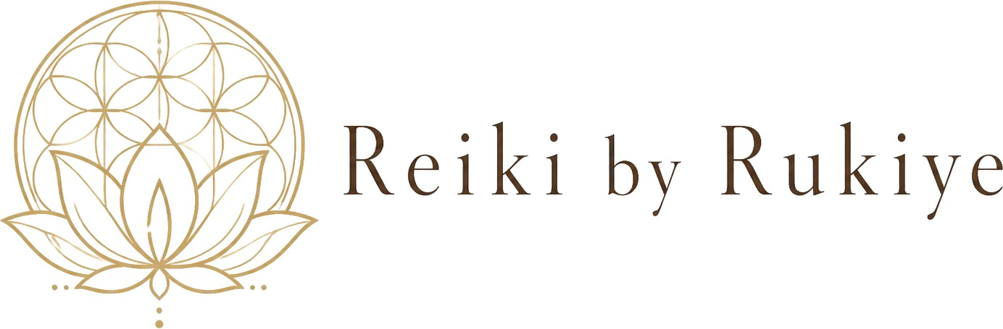
CLIENT INTAKE FORM

DISCLAIMER: Thank you for your interest in being a client of Reiki by Rukiye. This form is used to collect information about new clients for internal purposes only and to be kept confidential.

PERSONAL INFORMATION

Name: __________________________________ Gender: ☐ Male ☐ Female ☐ Other

Street Address: _______________________________________________________

City: ____________________ Prov: ____________ Postal Code: _______________

E-Mail: ____________________________________ Phone: ____________________

Date of Birth: ____/____/____ (Day/Month/Year)

SERVICE REQUEST

What is the reason for seeking our services?

How did you hear about us? _______________________________________________

- I understand that Reiki is a simple, gentle, hands-on energy technique that is used for stress reduction and relaxation.

- I understand that Reiki practitioners do not diagnose conditions nor do they prescribe or perform medical treatment.

Page 1 of 2
- I understand that Reiki does not take the place of medical or psychological care.

- I understand that Reiki can complement any medical or psychological care that I may be receiving.

- I understand that the body has the ability to heal itself and to do so, complete relaxation is often beneficial.

- I acknowledge that long term imbalances in the body sometimes requires multiple sessions in order to facilitate the level of relaxation needed by the body to heal itself.

- If client is a minor a parent or guardian must sign

Privacy Notice:

- No information about any client will be discussed or shared with any third party without written consent of the client or parent/guardian if the client is under 18.

Signature___________________________________ Date_____________________

Page 2 of 2

